|  |  |
| --- | --- |
| **Title:** | **Window Lifter Controller** |

**1.- PURPOSE………………………………………………………………………….………………………..4**

**2.-DEFINITIONS AND ABREVIATIONS…………………………………………….……………………….4**

**3.-REALIZATION CONSTRAINTS AND TARGETS………………………………………………………..5**

**4.-SW CONCEPTUAL DESIGN……………………………………………………………………………….6**

**5.- SW Component internal breakdown……………………………………………………………………7**

**5.1.- Diagrams by component…………………………..…………………………………………..7**

**5.1.1.-Complet Diagram…………………………………………………………………………..….8**

## 5.2.- Functional Decomposition…………………………………………………………………………….10

**5.3.- Function Description and Dynamic Behavior……………………………………………………..12**

## 5.3.1- Function voidappUpDown_void_manualUp()……………………………….……………………12

## 5.3.2.- Function void appUpDown_void_manualDown()…………………..……..……………………12

## 5.3.3.- Function T_U32 appUpDown_u32_PushUpButton()…………………...………………………13

## 5.3.4.-FunctionT_U32appUpDown_u32_PushDownButton()……….…………………………………14

## 5.3.5.- Function T_U32 appUpDown_u32_PushAntipinch()……………………………………………14

## 5.3.6.- Function void appUpDown_void_default_Leds(T_U32 led)………………..………….………15

## 5.3.7.- Function void appUpDown_void_clearGPIO()………………………………...…………….……16

## 5.3.8.- Function void appUpDown_void_timer1()……………………………………..……………..…..16

**5.3.9.- Function void appUpDown_void_timer0()………………………………………….…..…………17**

## 5.3.10.- Function T_U32 appUpDown_u32_validation10ms()…………………………………..……….18

## 5.3.11.- Function T_U32 appUpDown_u32_validation500ms()…………………………………………18

## 5.3.12.- Function T_U32 halWinMov_u32_ValidateUpButton()………………………….………..……19

## 5.3.13.- Function T_U32 halWinMov_u32_ValidateUpButton()………………..………..………………20

## 5.3.14.- Function T_U32 halWinMov_u32_ValidateAntipinch()*……………*……………..……20

## 5.3.15.- Function void halWinMov_void_ToggleBlueLed(T_U32 u32_status)…………..……21

## 5.3.16.- Function void halWinMov_void_ToggleRedLed(T_U32 u32_status)…………………22

## 5.3.17.- Function void halWinMov_void_ToggleGreenLed(T_U32 u32_status)…………………22

## 5.3.18.- Function void halWinMov_void_ToggleLedBar#(T_U32 u32_status)……………...……23

## 5.3.19 .- Function void main_void_onetouchUp()*……………..………………*…………...……24

## 5.3.20.- Function void main_void_onetouchDown()…………………………………………...……25

## 5.3.21.- Function void main_void_behaviorUp()….…………………………………………………..26

## 5.3.22.- Function void main_void_behaviorDown()….…………………………………………………..26

## 5.3.23.- Function void main_void_Antipinch()….…………………………………………………..27

## 5.3.24.- Function void main_void_idleState()….…………………………………………………..27

|  |  |  |  |  |
| --- | --- | --- | --- | --- |
| **History** | | | | |
| **Issue status**  (Index) | **Maturity/Date**  (draft/invalid/valid)  (dd-mmm-yyyy) | **Author**  Department | **Check/Release**  Department | **Description** |
| 1.0 | Draft  04-0ct-09 | Miguel Garcia | Miguel Garcia | Creation of the document. |
| 2.0 | Draft  26-Oct-17 | Rodrigo Mortera | Rodrigo Mortera | Insert Diagrams. |
| 2.1 | Draft  27-Oct-17 | Rafael Sanchez | Rafael Sanchez | Add function descriptions.­­­­­­ |
| 2.2 | Draft  28-Oct-17 | Rodrigo Mortera | Rodrigo Mortera | Updates Diagrams |
| 2.3 | Draft  29-Oct-17 | Rafael Sanchez | Rafael Sanchez | Updates function descriptions and Add flow chart to each function. |
| 3 | Draft 1-Nov.17 | Rodrigo Mortera | Rodrigo Mortera | Update Diagrams |
| 3-1 | Draft 2-Nov-17 | Rafael Sanchez | Rafael Sanchez | Update Diagrams |

**Table of Contents**

# Purpose

This document explains how the window lifter works and also describe each function through the layer programming method.

# Definitions and abbreviations

**Definitions**

|  |  |
| --- | --- |
| *BlueLed* | *Define to identify the port for the Blue Led* |
| *RedLed* | *Define to identify the port for the Red Led* |
| *GreenLed* | *Define to identify the port for the Green Led* |
| *UpButton* | *Define to identify the port for the push button 12* |
| *DownButton* | *Define to identify the port for the push button 13* |
| *LedBar_1* | *Define to identify the port for the Bar’s first Led* |
| *LedBar_2* | *Define to identify the port for the Bar’s secondary Led* |
| *LedBar_3* | *Define to identify the port for the Bar’s third Led* |
| *LedBar_4* | *Define to identify the port for the Bar’s fourth Led* |
| *LedBar_5* | *Define to identify the port for the Bar’s fifth Led* |
| *LedBar_6* | *Define to identify the port for the Bar’s sixth Led* |
| *LedBar_7* | *Define to identify the port for the Bar’s seventh Led* |
| *LedBar_8* | *Define to identify the port for the Bar’s eighth Led* |
| *LedBar_9* | *Define to identify the port for the Bar’s ninth Led* |
| *LedBar_10* | *Define to identify the port for the Bar’s tenth Led* |
| *SOSC_init_8MHz* | *Clock of 8Mhz* |
| *SPLL_init_160MHz* | *Clock of 160Mhz* |
| *NormalRUNmode_80MHz* | *Set the mode of the timer to normal with 8Mhz* |
| *malGPIO_init_void_LPIT0_init* | *Initialize timers* |
| *u32_lpit0_ch0_flag_counter* | *Variable to control timer 0* |
| *u32_lpit0_ch1_flag_counter* | *Variable to control timer 1* |
| *appButtons_u8_PushDownButton()* | *Read if Down Button is pushed* |
| *appButtons_u8_PushUpButton()* | *Read if Up Button is pushed* |
| *appUpDown_u8_OneTouchUp()* | *Ascending turn on the LedBar leds with just one touch* |
| *appUpDown_u8_OneTouchDown()* | *Descending turn on the LedBar leds with just one touch* |
| *appUpDown_u8_BehaviorUp()* | *Select the turn on leds behavior.* |
| *appUpDown_u8_BehaviorDown()* | *Select the turn off leds behavior.* |
| *main_void_antiPinch()* | *Do the antipinch action* |
| *main_void_idleState()* | *Put the program in an idle state* |
| *appUpDown_u8_ManualUp()* | *Ascending turn on the LedBar leds manually* |
| *appUpDown_u8_ManualDown()* | *Descending turn on the LedBar leds manually* |
| *appUpDown_u8_Antipinch();* | *Check antipinch* |
| *appUpDown_u8_5sec()* | *Wait 5 secondes* |
| *appUpDown_u8_Init()* | *Idle function* |
| *appTimer_void_set_timer1()* | *Increase the variable u32_lpit0_ch1_flag_counter each 1 ms* |
| *appTimer_void_clear_timer1()* | *Clean the variable u32_lpit0_ch1_flag_counter each 1 ms* |
| *appTimer_void_set_timer0()* | *Increase the variable u32_lpit0_ch0_flag_counter each 1 ms* |
| *appTimer_void_clear_timer0()* | *Clear the variable u32_lpit0_ch1_flag_counter each 1 ms* |

**Abbreviations**

|  |  |
| --- | --- |
| CH1 | Channel1 |
| CH2 | Channel2 |
| R&D | Research and Develop |
| STM | State Machine |

**References**

|  |  |  |
| --- | --- | --- |
| **N°** | **Document name** | **Reference** |
| *1* | *USER_GUIDE_S32K144* | [Link](https://www.nxp.com/products/microcontrollers-and-processors/arm-based-processors-and-mcus/s32-automotive-processors-and-microcontrollers/32-bit-automotive-general-purpose-microcontrollers:S32K?tab=Documentation_Tab) |
| 2 | [***S32K14x Series Reference Manual***](https://www.nxp.com/docs/en/reference-manual/S32K-RM.pdf) |
| 3 | [***S32K1xx Data Sheet***](https://www.nxp.com/docs/en/data-sheet/S32K-DS.pdf) |
| 4 | ***AN5413, s32k14x Series Cookbook*** |

# Realization constraints and targets

The objective of the task is to achieve to lift and down a window car simulated by 10 red LedBar regarding to the customer request. The development of the project must be on the Development Kit Platform S32K144EVB NXP microcontroller provided by Continental R&D.

# SW Conceptual design

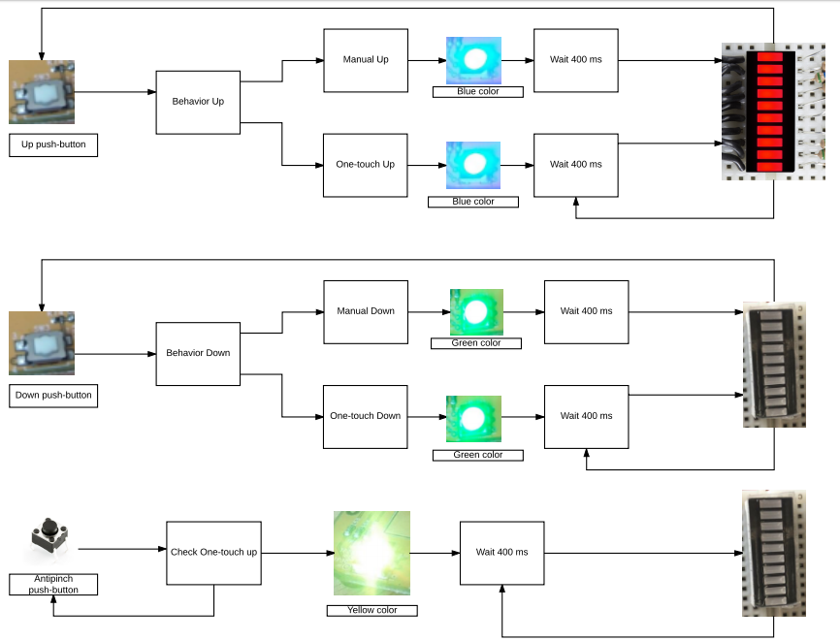

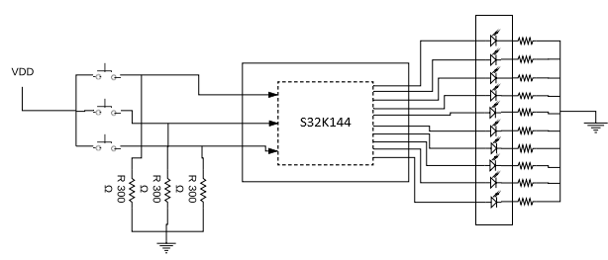

1. **SW Component internal breakdown**
   1. **Diagrams by component**

Blue Led.

Lines and Functions related with Down behavior and green led.

Lines and Functions related with Up behavior.

Lines and Functions related with Antipinch behavior.

Red Led.

Timer functions and void function.

Status output port led’s function.

State functions

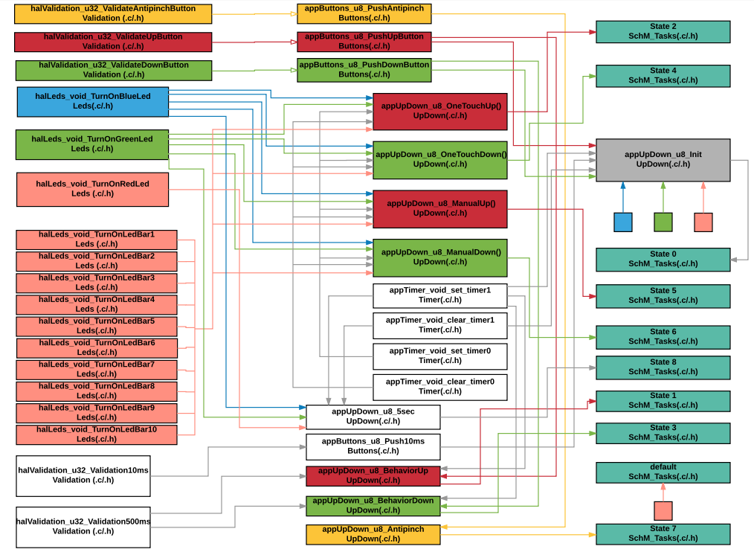

## Functional Decomposition

Black Line makes reference to appUpDown_void_clearGPIO() function.

Blue Line makes reference to appUpDown_void_default_Leds() function.

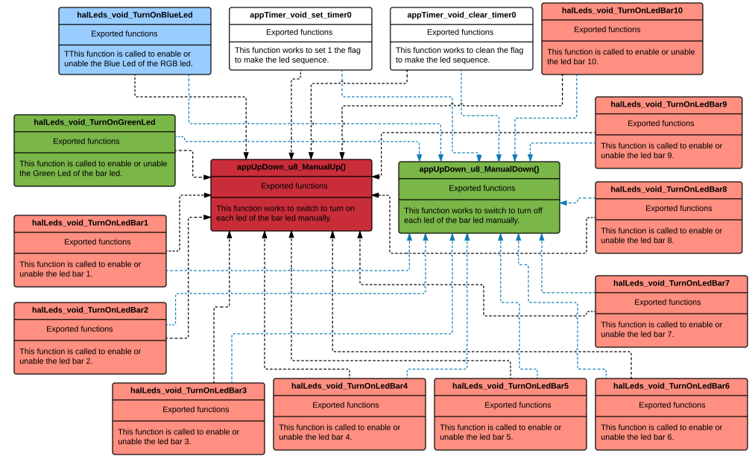

Blue Line makes reference to appUpDown_void_default_Leds() function.

Black Line makes reference to appUpDown_void_clearGPIO() function.

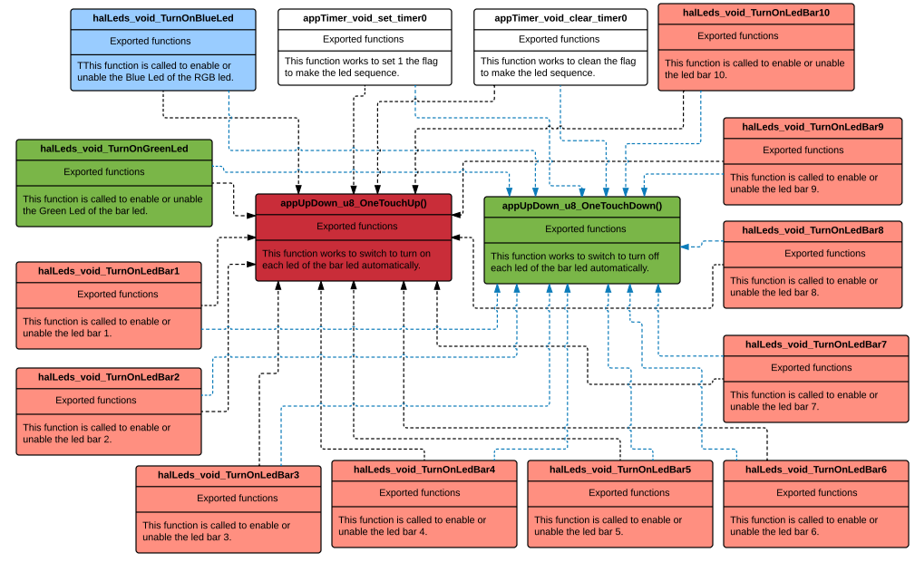

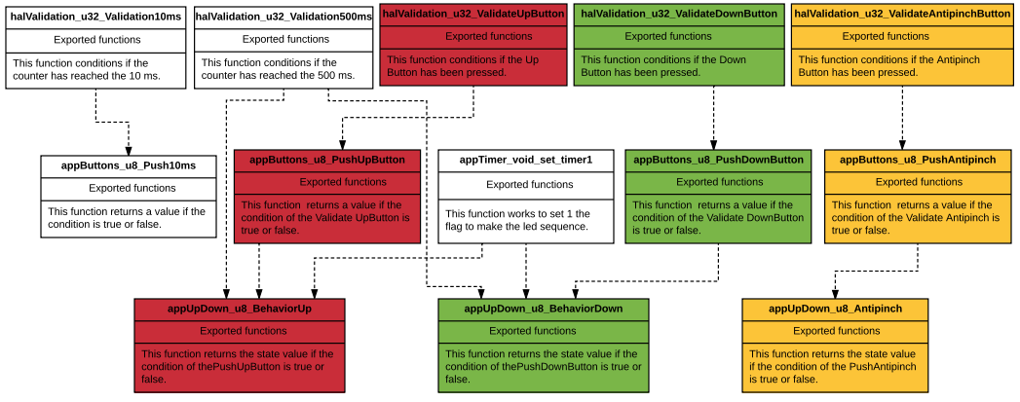

## 

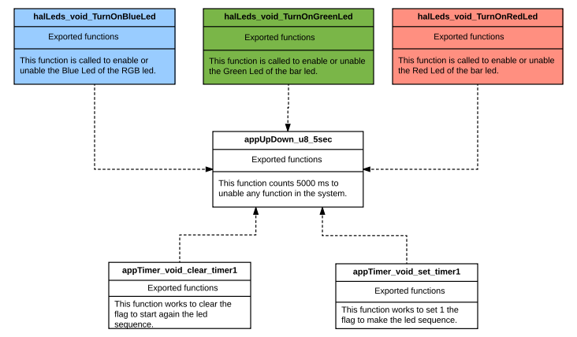

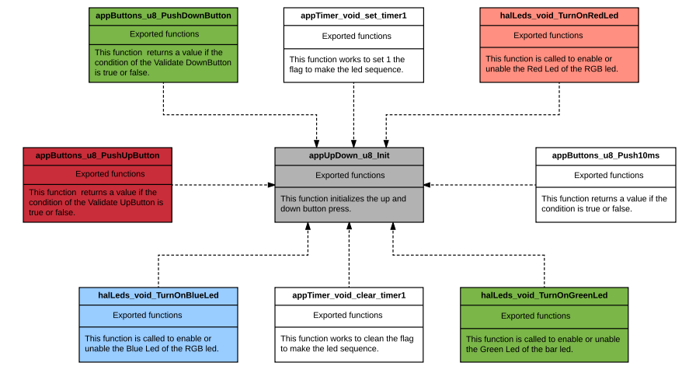

**5.2 STATE MACHINE**







**The manual Up and manual Down are the same as One Touch Up and One Touch Down.**

* 1. **Function Description and Dynamic Behavior**

## Function T_UBYTE appUpDown_u8_ManualUp()

|  |  |
| --- | --- |
| **Description** | Manually Ascending Turn on the Led Bar using a switch statement, the Led number is proportional with s32_switchFlag value. With the manage variable indicate which is the state of STM.  Possible state = 0, 5 |
| **Return Value** | T_UBYTE manage |
| **Precondition** | The s32_switchFlag has to be set with a value [-1 to 9] |
| **Post condition** | The LedBar X is turned on. |
| **Error Conditions** |  |

**Dynamic Behavior**

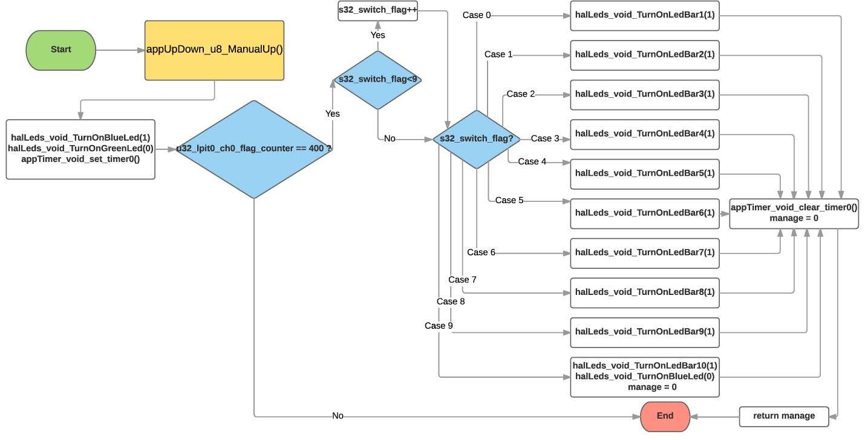

## Function T_UBYTE appUpDown_u8_ManualDown()

|  |  |
| --- | --- |
| **Description** | Manually Descending Turn on the Led Bar using a switch statement, the Led number is proportional with s32_switchFlag value. With the manage variable indicate which is the state of STM. Possible state = 0, 6 |
| **Return Value** | T_UBYTE manage |
| **Precondition** | The s32_switchFlag has to be set with a value [-1 to 9] |
| **Post condition** | The ledbar is turned off. |
| **Error Conditions** |  |

**Dynamic Behavior**

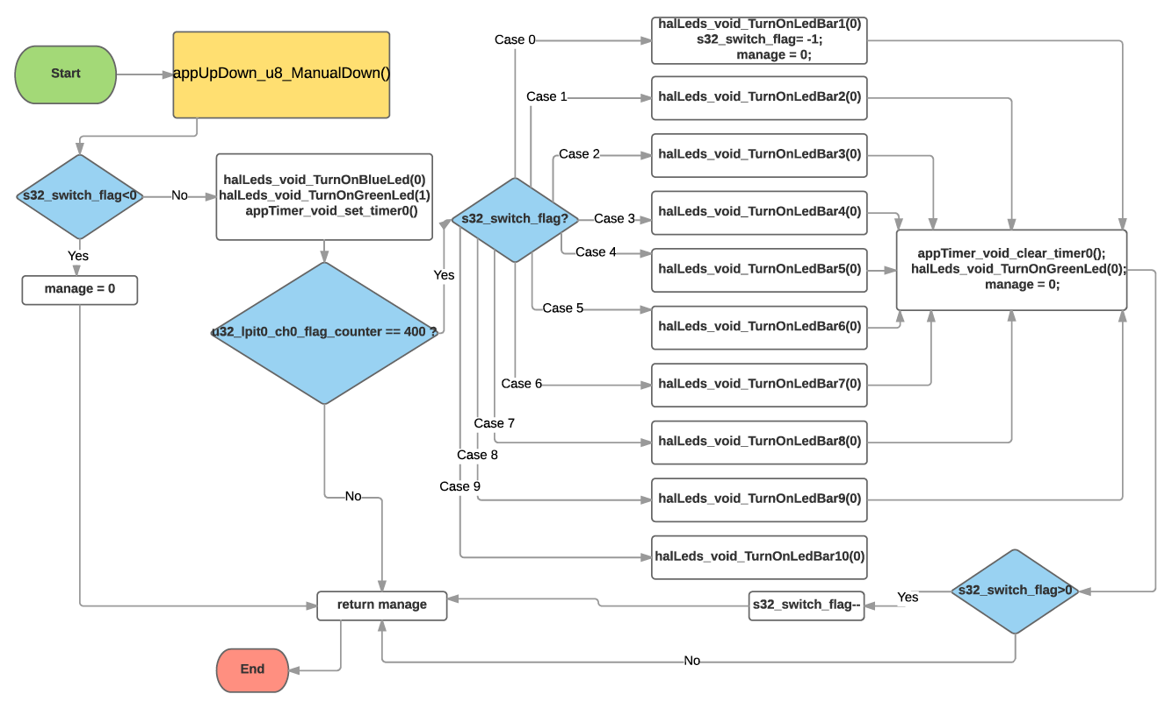

## Function T_UBYTE appUpDown_u8_BehaviorUp()

|  |  |
| --- | --- |
| **Description** | Select Behavior Up (Manual UP or One Touch Up). With the manage variable indicate which is the state of STM. The possible states = 1, 7, 5 |
| **Parameter 1** <input| output| inout> |  |
| **Parameter 2..n** |  |
| **Return Value** | T_UBYTE manage |
| **Precondition** |  |
| **Post condition** |  |
| **Error Conditions** |  |

**Dynamic Behavior**

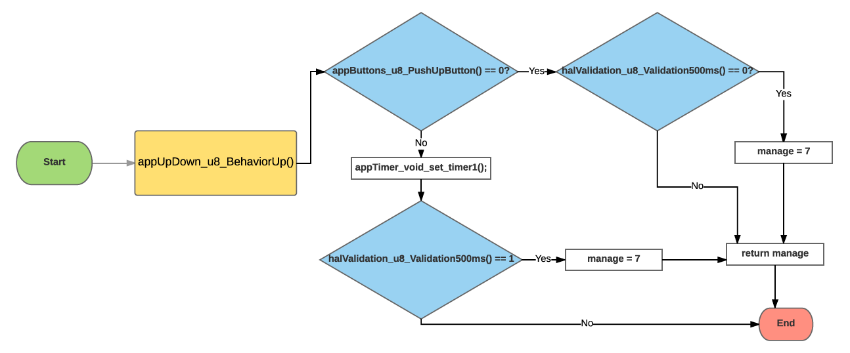

## Function T_UBYTE appUpDown_u8_BehaviorDown()

|  |  |
| --- | --- |
| **Description** | Select Behavior Down (Manual Down or One Touch Down). With the manage variable indicate which is the state of STM. The possible states = 3, 4, 6 |
| **Parameter 1** <input| output| inout> |  |
| **Parameter 2..n** |  |
| **Return Value** | T_UBYTE manage |
| **Precondition** |  |
| **Post condition** |  |
| **Error Conditions** |  |

**Dynamic Behavior**

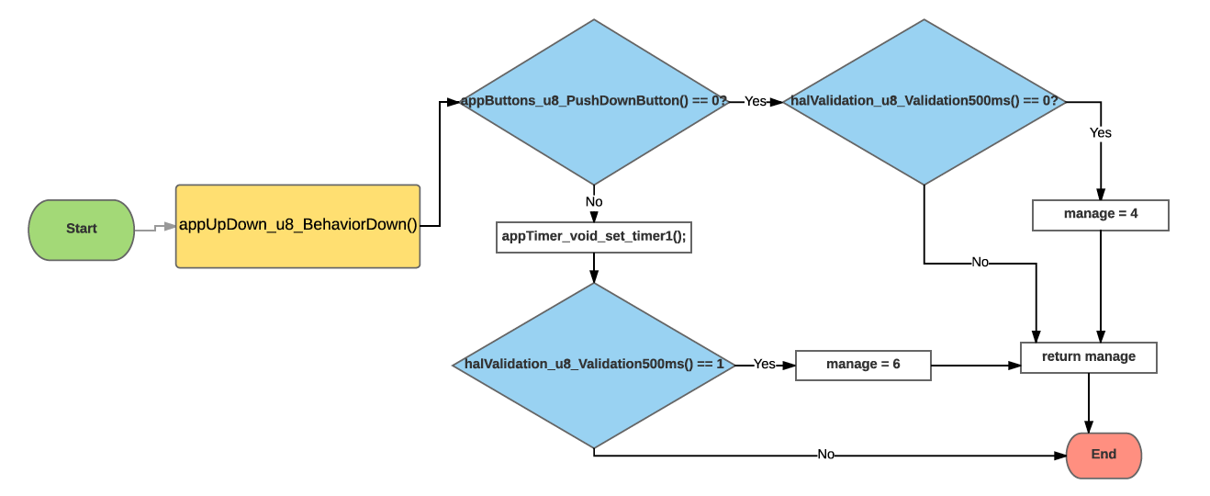

## Function T_UBYTE appUpDown_u8_OneTouchUp()

|  |  |
| --- | --- |
| **Description** | Automatically Ascending Turn on the Led Bar using a switch statement, the Led number is proportional with s32_switchFlag value. With the manage variable indicate which is the state of STM.  Possible state = 0, 2, 7. |
| **Parameter 1** <input| output| inout> |  |
| **Parameter 2..n** |  |
| **Return Value** | T_UBYTE manage |
| **Precondition** |  |
| **Post condition** |  |
| **Error Conditions** |  |

**Dynamic Behavior**

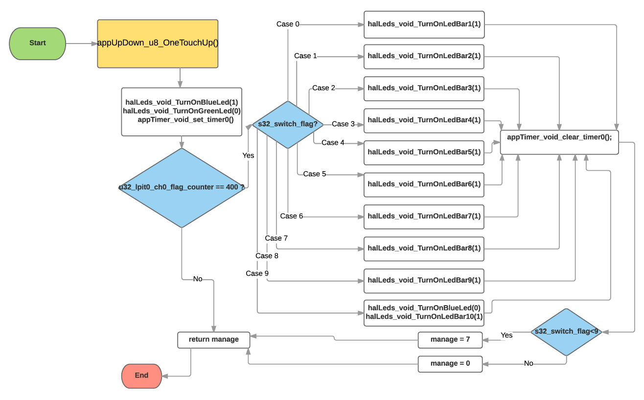

## Function T_UBYTE appUpDown_u8_OneTouchDown()

|  |  |
| --- | --- |
| **Description** | Automatically Descending Turn off the Led Bar using a switch statement, the Led number is proportional with s32_switchFlag value. With the manage variable indicate which is the state of STM.  Possible state = 0, 4 |
| **Parameter 1** <input| output| inout> |  |
| **Parameter 2..n** |  |
| **Return Value** | T_UBYTE manage |
| **Precondition** |  |
| **Post condition** |  |
| **Error Conditions** |  |

**Dynamic Behavior**

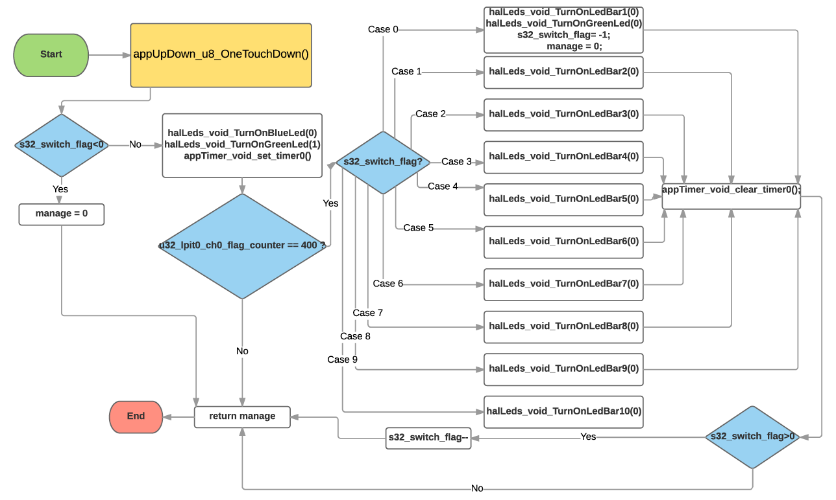

## Function T_UBYTE appUpDown_u8_Antipinch()

|  |  |
| --- | --- |
| **Description** | Route to appUpDown_u8_OneTouchDown() or appUpDown_u8_OneTouchUp(). With the manage variable indicate which is the state of STM. Possible state = 2, 4, 7 |
| **Parameter 1** <input| output| inout> |  |
| **Parameter 2..n** |  |
| **Return Value** | T_UBYTE manage |
| **Precondition** | *The Antipinch buttons should be pushed* |
| **Post condition** |  |
| **Error Conditions** |  |

**Dynamic Behavior**

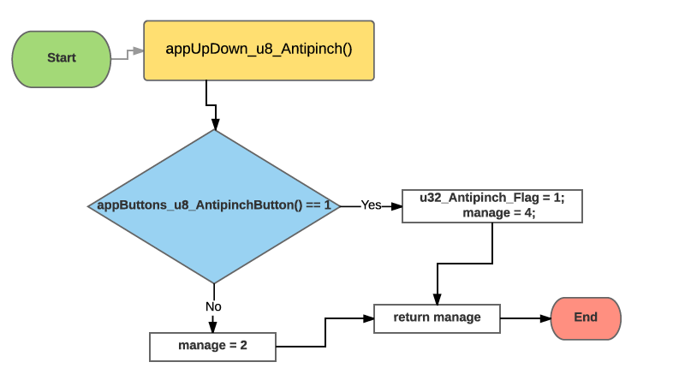

## Function T_UBYTE appUpDown_u8_5sec()

|  |  |
| --- | --- |
| **Description** | Ignore all the push buttons during 5 seconds. With the manage variable indicate which is the state of STM. Possible state = 0, 8 |
| **Parameter 1** <input| output| inout> |  |
| **Parameter 2..n** |  |
| **Return Value** | T_UBYTE manage |
| **Precondition** | *The appUpDown_u8_Antipinch() should have been callback* |
| **Post condition** |  |
| **Error Conditions** |  |

**Dynamic Behavior**

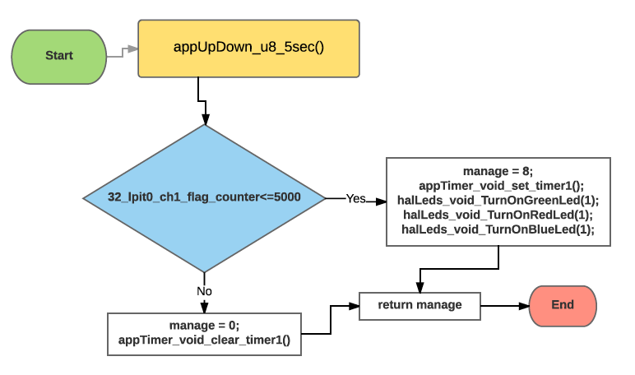

## Function T_UBYTE appUpDown_u8_Init()

|  |  |
| --- | --- |
| **Description** | Selects between apUpDown_u8_BehaviorUp(), appUpDown_u8_BehaviorDown(), or put in Idle state (when any button is pressed) With the manage variable indicate which is the state of STM. Possible state = 0, 1, 3, 8 |
| **Parameter 1** <input| output| inout> |  |
| **Parameter 2..n** |  |
| **Return Value** | T_UBYTE manage |
| **Precondition** |  |
| **Post condition** |  |
| **Error Conditions** |  |

**Dynamic Behavior**

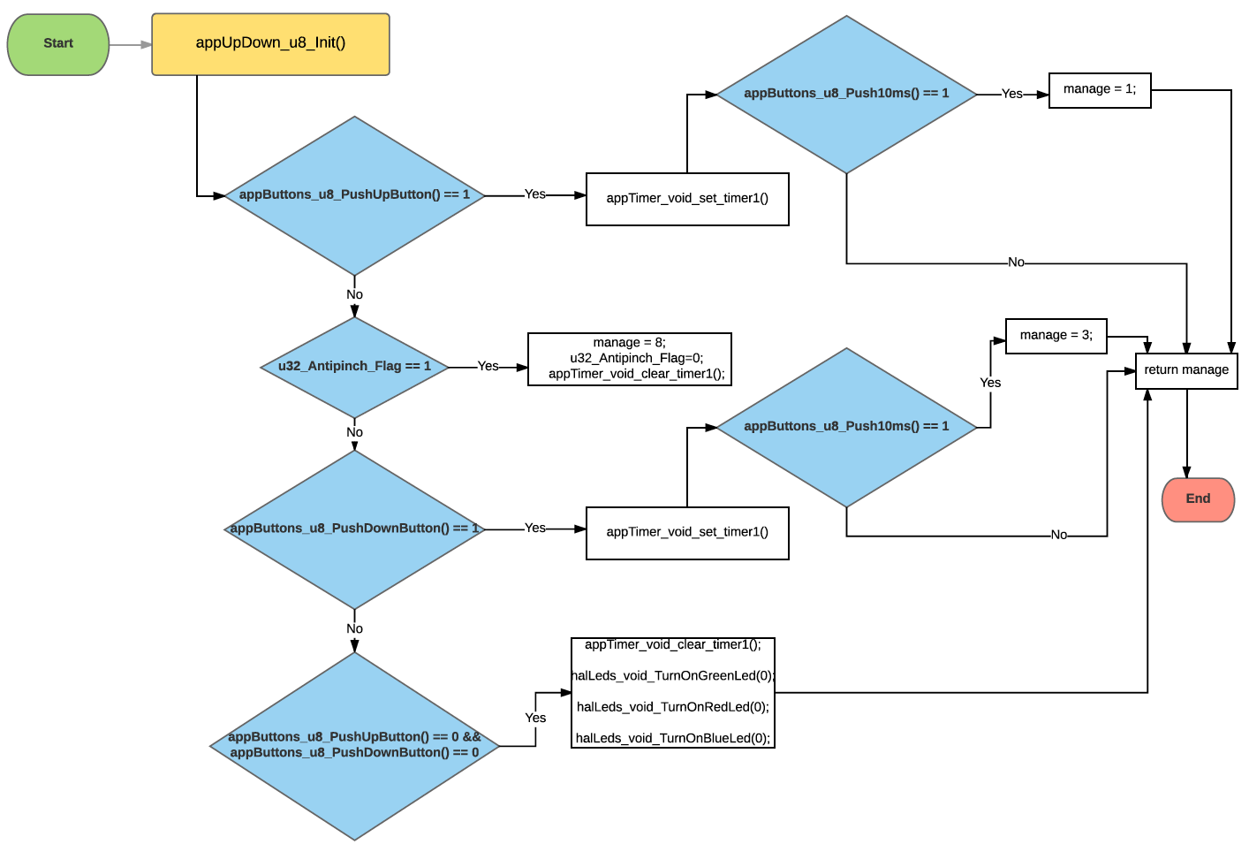

## Function T_UBYTE appButtons_u8_PushUpButton()

|  |  |
| --- | --- |
| **Description** | Calls halValidation_u8_ValidateUpButton() function to know if it is True or False |
| **Parameter 1** <input| output| inout> |  |
| **Parameter 2..n** |  |
| **Return Value** | T_UBYTE 1, 0 |
| **Precondition** |  |
| **Post condition** |  |
| **Error Conditions** |  |

**Dynamic Behavior**

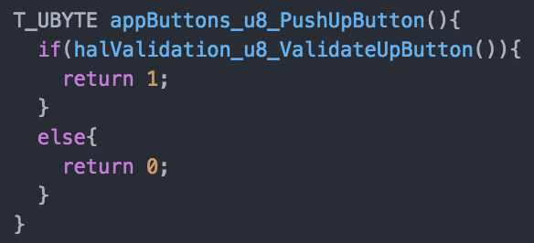

## Function T_UBYTE appButtons_u8_PushDownButton()

|  |  |
| --- | --- |
| **Description** | Calls halValidation_u8_ValidateDownButton() function to know if it is True or False |
| **Parameter 1** <input| output| inout> |  |
| **Parameter 2..n** |  |
| **Return Value** | T_UBYTE 1, 0 |
| **Precondition** |  |
| **Post condition** |  |
| **Error Conditions** |  |

**Dynamic Behavior**

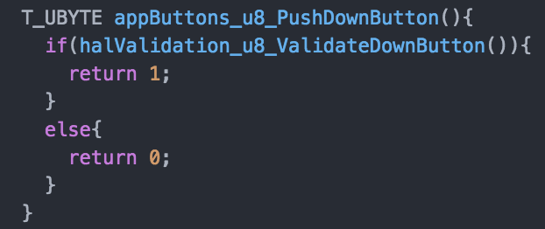

## Function T_UBYTE appButtons_u8_AntipinchButton()

|  |  |
| --- | --- |
| **Description** | Calls halValidation_u8_ValidateAntipinchButton() function to know if it is True or False |
| **Parameter 1** <input| output| inout> |  |
| **Parameter 2..n** |  |
| **Return Value** | T_UBYTE 1, 0 |
| **Precondition** |  |
| **Post condition** |  |
| **Error Conditions** |  |

**Dynamic Behavior**

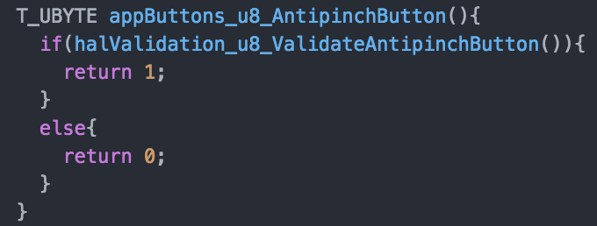

## Function T_UBYTE appButtons_u8_Push10ms()

|  |  |
| --- | --- |
| **Description** | Calls halValidation_u8_Validation10ms() function to know if it is True or False |
| **Parameter 1** <input| output| inout> |  |
| **Parameter 2..n** |  |
| **Return Value** | T_UBYTE 1, 0 |
| **Precondition** |  |
| **Post condition** |  |
| **Error Conditions** |  |

**Dynamic Behavior**

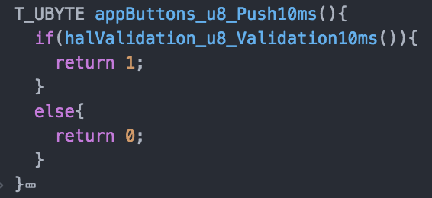

## Function void appTimer_void_set_timer1()

|  |  |
| --- | --- |
| **Description** | Increment u32_lpit0_ch1_flag_counter variable |
| **Parameter 1** <input| output| inout> |  |
| **Parameter 2..n** |  |
| **Return Value** | void |
| **Precondition** |  |
| **Post condition** |  |
| **Error Conditions** |  |

**Dynamic Behavior**

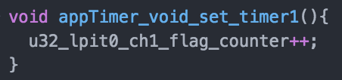

## Function void appTimer_void_set_timer0()

|  |  |
| --- | --- |
| **Description** | Increment u32_lpit0_ch0_flag_counter variable |
| **Parameter 1** <input| output| inout> |  |
| **Parameter 2..n** |  |
| **Return Value** | void |
| **Precondition** |  |
| **Post condition** |  |
| **Error Conditions** |  |

**Dynamic Behavior**

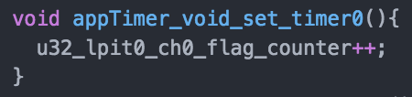

## Function void appTimer_void_clear_timer1()

|  |  |
| --- | --- |
| **Description** | Clear u32_lpit0_ch1_flag_counter variable |
| **Parameter 1** <input| output| inout> |  |
| **Parameter 2..n** |  |
| **Return Value** | void |
| **Precondition** |  |
| **Post condition** |  |
| **Error Conditions** |  |

**Dynamic Behavior**

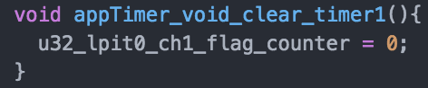

## Function void appTimer_void_clear_timer0()

|  |  |
| --- | --- |
| **Description** | Clear u32_lpit0_ch0_flag_counter variable |
| **Parameter 1** <input| output| inout> |  |
| **Parameter 2..n** |  |
| **Return Value** | void |
| **Precondition** |  |
| **Post condition** |  |
| **Error Conditions** |  |

**Dynamic Behavior**

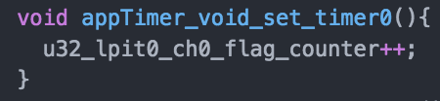

## Function void halLeds_void_TurnOnBlueLed(T_UBYTE u8_status)

|  |  |
| --- | --- |
| **Description** | Calls  - Dio_PortSetPin(PORTCH_D, BlueLed) if status = 1.  - Dio_PortClearPin(PORTCH_D, BlueLed) if status = 0. |
| **Parameter 1** <input| output| inout> | Input T_ UBYTE u8_status |
| **Parameter 2..n** |  |
| **Return Value** | void |
| **Precondition** | Include the functions  Dio_PortSetPin(DioPortType DioPort, uint32_t DioPin)  Dio_PortSetPin(DioPortType DioPort, uint32_t DioPin) |
| **Post condition** |  |
| **Error Conditions** |  |

**Dynamic Behavior**

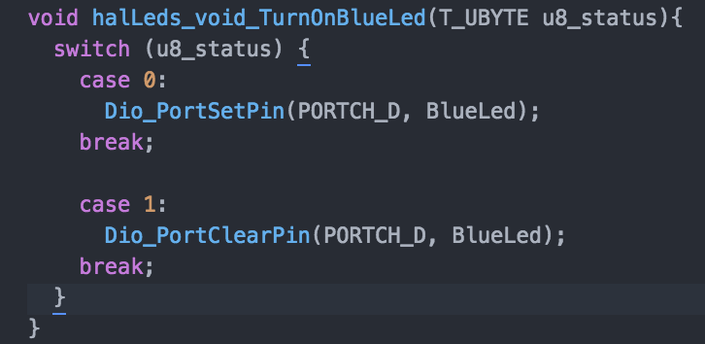

## Function void halLeds_void_TurnOnRedLed(T_UBYTE u8_status)

|  |  |
| --- | --- |
| **Description** | Calls  - Dio_PortSetPin(PORTCH_D, RedLed) if status = 1.  - Dio_PortClearPin(PORTCH_D, RedLed) if status = 0. |
| **Parameter 1** <input| output| inout> | Input T_ UBYTE u8_status |
| **Parameter 2..n** |  |
| **Return Value** | void |
| **Precondition** | Include the functions  Dio_PortSetPin(DioPortType DioPort, uint32_t DioPin)  Dio_PortSetPin(DioPortType DioPort, uint32_t DioPin) |
| **Post condition** |  |
| **Error Conditions** |  |

**Dynamic Behavior**

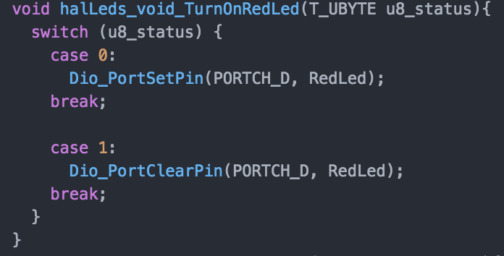

## Function void halLeds_void_TurnOnGreenLed(T_UBYTE u8_status)

|  |  |
| --- | --- |
| **Description** | Calls  - Dio_PortSetPin(PORTCH_D, GreenLed) if status = 1.  - Dio_PortClearPin(PORTCH_D, GreenLed) if status = 0. |
| **Parameter 1** <input| output| inout> | Input T_ UBYTE u8_status |
| **Parameter 2..n** |  |
| **Return Value** | void |
| **Precondition** | Include the functions  Dio_PortSetPin(DioPortType DioPort, uint32_t DioPin)  Dio_PortSetPin(DioPortType DioPort, uint32_t DioPin) |
| **Post condition** |  |
| **Error Conditions** |  |

**Dynamic Behavior**

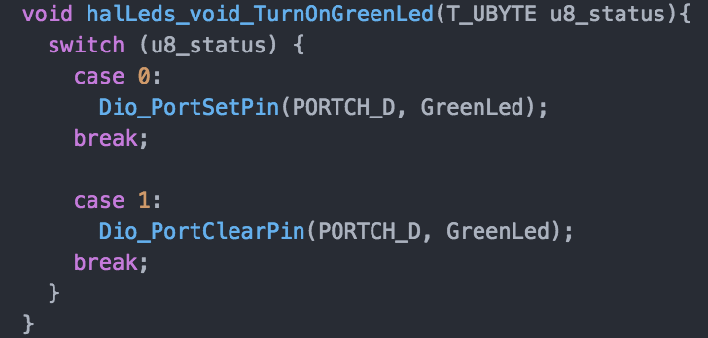

## Function void halLeds_void_TurnOnLedBarX(T_UBYTE u8_status)

|  |  |  |
| --- | --- | --- |
| **Description** | Calls Dio_PortSetPin(DioPortType DioPort, uint32_t DioPin) and Dio_PortClearPin(DioPortType DioPort, uint32_t DioPin) | |
| LedBar_1:  DioPort = PORTCH_C  DioPin = LedBar_1  LedBar_2:  DioPort = PORTCH_B  DioPin = LedBar_2  LedBar_3:  DioPort = PORTCH_B  DioPin = LedBar_3  LedBar_4:  DioPort = PORTCH_B  DioPin = LedBar_4  LedBar_5:  DioPort = PORTCH_B  DioPin = LedBar_5 | LedBar_6:  DioPort = PORTCH_C  DioPin = LedBar_6  LedBar_7:  DioPort = PORTCH_C  DioPin = LedBar_7  LedBar_8:  DioPort = PORTCH_E  DioPin = LedBar_8  LedBar_9:  DioPort = PORTCH_E  DioPin = LedBar_9  LedBar_10:  DioPort = PORTCH_4  DioPin = LedBar_10 |
| **Parameter 1** <input| output| inout> | Input T_ UBYTE u8_status | |
| **Parameter 2..n** |  | |
| **Return Value** | void | |
| **Precondition** | Include the functions  Dio_PortSetPin(DioPortType DioPort, uint32_t DioPin)  Dio_PortSetPin(DioPortType DioPort, uint32_t DioPin) | |
| **Post condition** |  | |
| **Error Conditions** |  | |

**Dynamic Behavior**

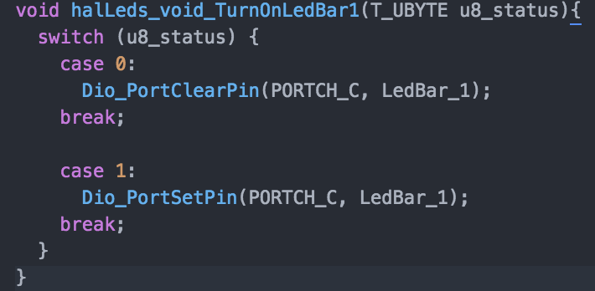

## Function T_UBYTE halValidation_u8_ValidateUpButton()

|  |  |
| --- | --- |
| **Description** | Check if PORT C12 value is in High or Low and returns 1 if is High and 0 if is Low |
| **Parameter 1** <input| output| inout> |  |
| **Parameter 2..n** |  |
| **Return Value** | T_UBYTE 1,0 |
| **Precondition** | The PORTD C12 should be configured as input. |
| **Post condition** |  |
| **Error Conditions** |  |

**Dynamic Behavior**

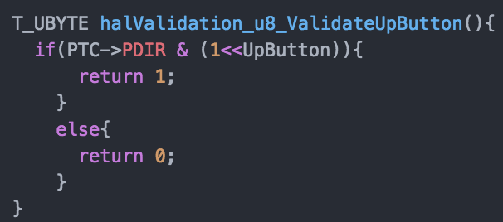

## Function T_UBYTE halValidation_u8_ValidateDownButton()

|  |  |
| --- | --- |
| **Description** | Check if PORT C13 value is in High or Low and returns 1 if is High and 0 if is Low |
| **Parameter 1** <input| output| inout> |  |
| **Parameter 2..n** |  |
| **Return Value** | T_UBYTE 1,0 |
| **Precondition** | The PORTD C13 should be configured as input. |
| **Post condition** |  |
| **Error Conditions** |  |

**Dynamic Behavior**

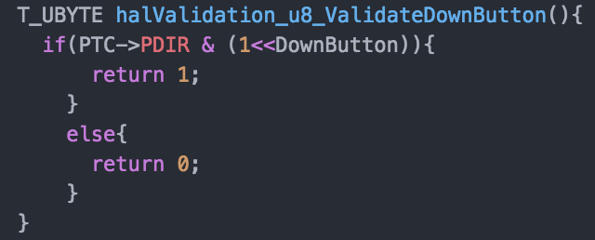

## Function T_UBYTE halValidation_u8_AntipinchButton()

|  |  |
| --- | --- |
| **Description** | Check if PORT E13 value is in High or Low and returns 1 if is High and 0 if is Low |
| **Parameter 1** <input| output| inout> |  |
| **Parameter 2..n** |  |
| **Return Value** | T_UBYTE 1,0 |
| **Precondition** | The PORTD E13 should be configured as input. |
| **Post condition** |  |
| **Error Conditions** |  |

**Dynamic Behavior**

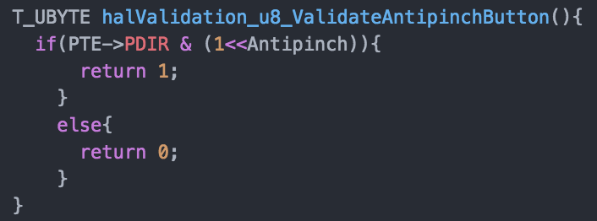

## Function T_UBYTE halValidation_u8_Validation10ms()

|  |  |
| --- | --- |
| **Description** | Check if u32_lpit0_ch1_flag_counter >= 10. If True return 1 else return 0 |
| **Parameter 1** <input| output| inout> |  |
| **Parameter 2..n** |  |
| **Return Value** | T_UBYTE 1,0 |
| **Precondition** |  |
| **Post condition** |  |
| **Error Conditions** |  |

**Dynamic Behavior**

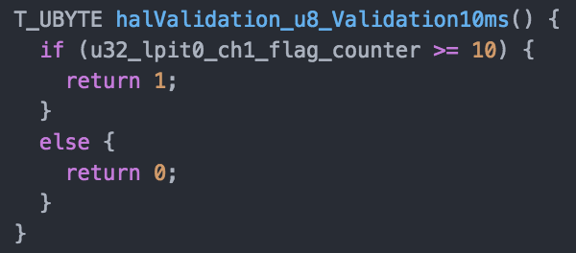

## Function T_UBYTE halValidation_u8_Validation500ms()

|  |  |
| --- | --- |
| **Description** | Check if u32_lpit0_ch1_flag_counter >= 500. If True return 1 else return 0 |
| **Parameter 1** <input| output| inout> |  |
| **Parameter 2..n** |  |
| **Return Value** | T_UBYTE 1,0 |
| **Precondition** |  |
| **Post condition** |  |
| **Error Conditions** |  |

**Dynamic Behavior**

